Custom Stirred Reactor
Stirred Reactor with Rotating Coupon Holder as per ASTM G170
PTFE lined reactor capacity 1000 ml rated for 140 bar at 200 Deg C. Magnetic drive 50 kgf-cm torque with rotating coupon holder of PTFE with internals of Hastelloy C276 to study corrosion of six coupons 19 mm W 76 mm L 3 mm T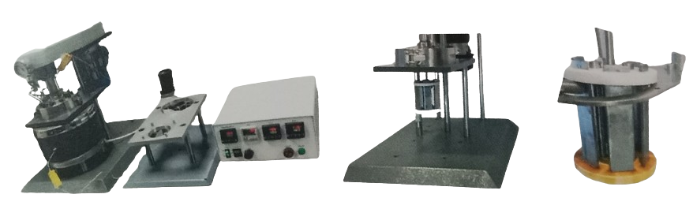
Customized horizontal tube stirred reactor
The reactor is provided with standard features like safety disc, gas inlet, liquid inlet, magnetic drive, thermocouple. The temperature control can be provided with welded jacket or electric heater. An additional liquid feed port can be provided above welded jacket to trickle liquid directly on worm. The tube can also be placed at 15 deg angle, to provide down ward thrust; useful for slurry or viscos liquid. The outlet port is ½” tube to be interfaced to two liter collection vessel under operating pressure.
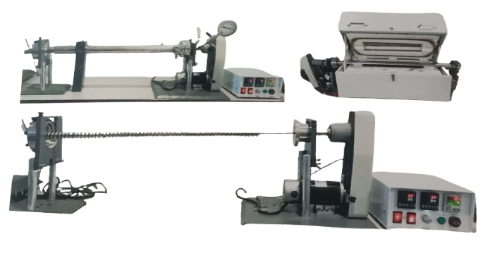Stirred Tube Reactor 800 mm with welded jacket Stirred Tube 1000 mm with Heater

Continuous Stirred Tank Reactor and
Continuous Fixed Bed Tube Reactor

With mass flow controller, liquid metering pump, gas/liquid separator and
back pressure regulator

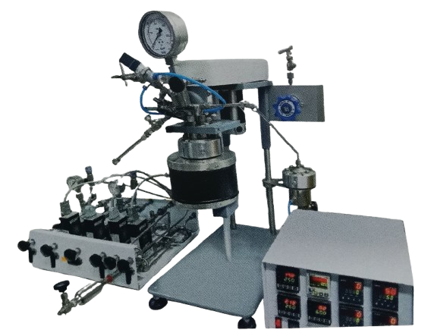Tube Reactor with heater, gas/liquid separator, and back pressure regulator
Stirred reactor with four MFC,
Gas/liquid separator,
Back pressure regulator,
Inlet gas mixture sampling,
Gas outlet sample,
Liquid sampling

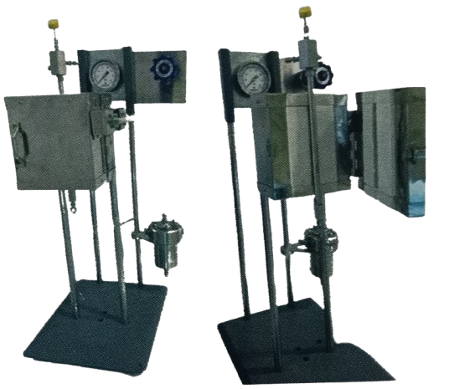

Tube reactor with heater,
Gas/liquid separator,
Back pressure regulator

Gas handling unit with four MFC, gas mixture sampling, gas outlet sample, liquid sampling
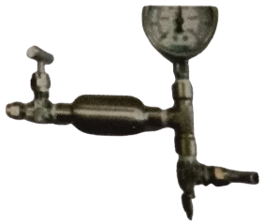
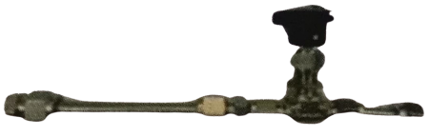
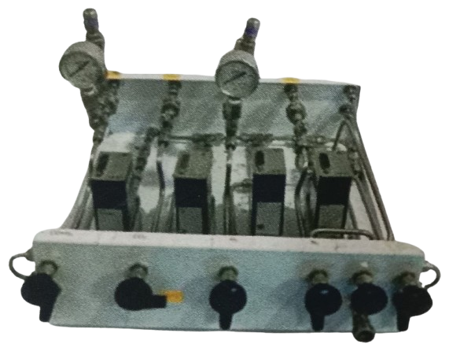

Liquid Sapling 3 mL
Outlet gas sampling bottle
Capacity 50 ml with septa
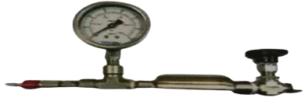
Inlet gas sampling with 50 ml bottle

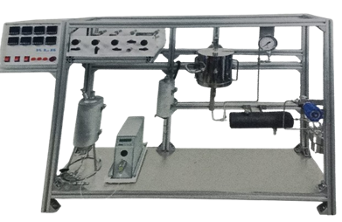
Continuous Flow High Pressure Tube Reactor

Tube reactor with four gas lines gas lines, mass flow controller, liquid feed tank with pre-heater, metering pump, gas pre-heater/mixer, tube furnace, condenser, gas/liquid separator, back pressure regulator, gas sampling unit

For continuous flow systems, tubular reactor have been developed with continuous reactor feed, a variety of pre- heat and heating options with sample collection systems and product handing single-phase flow in a tubular reactor can be upward or downward. Two-phase flow can be co-current up –flow, counter – current (liquid down, gas up) or most commonly, co-current down-flow. Tubular reactor can have a single wall and be heated with an external furnace or they can be jacketed for heating or cooling with a circulating heat transfer fluid. External furnace can be rigid, split- tube heater or be flexible mantle heaters.

The tube is available in Inconel 600, SS316, hastelloy C276. The tube is customized to user specification. Available internal diameter is 0.25”, 0.5”, 0.75” or 1”. Tube length can be customized as per user application. The HEX nut provided at end has port for thermowell, gas inlet, trickle feed inlet. Maximum operating pressure is 200 bar/3000 psi and maximum operating temperature can be 550 Deg C to 900 deg C.

Tubular reactor may be empty for homogenous reactions or packed with catalyst particles for heterogeneous reactions. Packed reactors require upper and lower supports to hold particles in place. Uppermost packing is often of inert material to serve as a pre-heat section.

It is often, desirable to size a tubular reactor to be large enough to fit 8 to 10 catalyst particles across the diameter and be at least 40- 50 particle diameters long. The length to diameter ratio can be varied to study the effect of catalyst loading.

Temperature is typically controlled by thermo-couples located on the outer wall of an eternally heated tubular rector. A moveable internal thermocouple is often employed to observe the temperature changes occurring as the reaction proceeds through the reactor.

Tubular reactor systems are highly customizable and can be made to various lengths and diameters and engineered for various pressure and temperatures. Indo can provide a split-tube furnace for heating these vessels.

Insulation is provided at each end so that the end caps are not heated to the same temperature as the core of the reactor. The heater length is normally divided into one, two, or three separate heating zones, although it can be split into as many zones as required.

We can furnish either a fixed internal thermos- couple in each zone or a single movable thermocouple that can be used to measure the temperature at points along the catalyst bed. External thermocouples are typically provided for control of each zone of the heater.

Gas feed systems

Various gas feeds can be set up and operated from a gas distribution cabinet. In order to deliver a constant flow of gas to a reactor, it is necessary to provide gas at a constant pressure to an electronic mass flow controller (MFC). This instrument will compare the actual flow rate delivered to the set point chosen by the user, and automatically adjust an integral control valve to assure a constant flow. Care must be taken to size these controllers for the specific gas, the flow rate, and the pressure of operation.

A mass flow controller needs a power supply and read-out device, as well as a means of introducing the desired set point.

When ordering mass flow controllers, you will need to specify:
- Type of gas to be metered (e.g. N2, H2, CH4)
- Maximum operating pressure of the gas (100 or 300 bar)
- Maximum flow rate range in standard cc’s per minute (sccm)
- Pressure for calibration of the instruments

MFC are available for use to 500 psi and to 4500 psi. Considerable savings can be obtained if the MFC is to be used only to 1000 psi. Along with MFC, a bypass line with metering valve is provided to by-pass MFC and introduce gas manually. This provision will enhance the system for rapid filling. Gas sampling port is provided to verify gas ratio at outlet.

A purge line can also be added. It is typically used for feeding nitrogen or helium to remove air before reaction or to remove reactive gases opening the reactor at the end of a run. The purge line includes a shut-off valve, metering valve, and a reverse h-flow check valve.

Liquid Metering Pumps

High pressure piston pumps are most often used or inject liquids into a pressurized reactor operating in a continuous-flow mode. For low flow rates, HPLC pumps, many of which are rated 5000 psig. Are excellent choices typical flow rates for pumps of this type range up to 10 or 40 mL per minute. Pumps are available to accommodate manual control from their digital faceplate or PLC/ computer-control.

Back pressure regulators in addition to supplying gases to a reaction through electronic mass flow controllers, the reactor is kept at a constant pressure by installing a back pressure regulator (BPR) downstream of the reactor. This style of regulator will release products only when the reactor pressure exceeds a preset valve. When a BPR is used in conjunction with mass flow controllers, the user is assured that a constant flow of gas is passing through a reactor, which is being help at a constant pressure. This provides for the highest degree of control and reproducibility in a continuous-flow reactor system.

Cooling condensers it is often desired to cool the products of the reaction prior to handling them. For this purpose, tube–and-shell heat exchangers are available to act as the cooling condensers. An adaptation of our standard condensers provides an excellent design.

Gas/liquid separators tubular reactors operating in continuous-flow mode with both gas and liquid products will also require a gas/liquid separator for smooth operation. The separator is placed downstream of the reactor, often separator form the reactor by a cooling condenser. In the separator vessel, liquids are condensed and collected in the bottom of the vessel. Gases and non-condensed vapors are allowed to leave the top of the vessel and pass to the back pressure regulator. It is important to operate the BPR with a single fluid phase to prevent oscillation of the reactor pressure. The gas/liquid separator can be sized large enough to act as a liquid product receiver that can be manually drained periodically. Many of the non-stirred pressure vessels made by ndo are ideally suited for use as gas/liquid separators. Vessels of 50,100,300, or 600 ml are commonly chosen.

Control and data acquisition systems a variety of solutions exist to meet the needs of system operators. Indo can provide 8x48 eight channel control system for three heater control, MFC control, pressure and temperature display. RS485 output port is provided for computer interface. This controller can be used for any generic use. Alternate a dedicated PLC control with computer is also available for customized reactor.

Accessories for Reactors
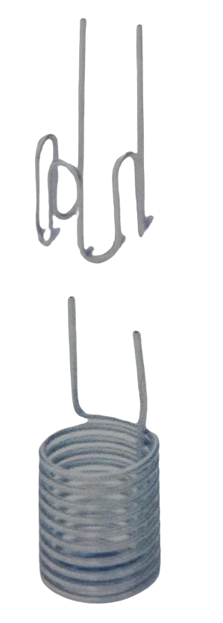
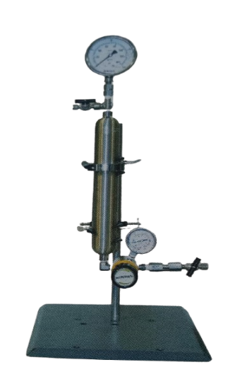
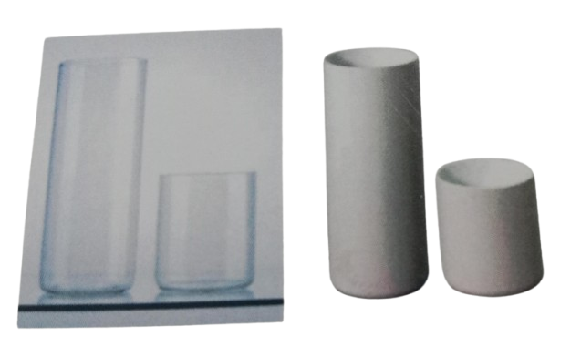

High pressure gas burettes – Indo offers a series of high-pressure burettes intended to introduce reactant gas top a reactor at a constant pressure.

The burettes consist of a high-pressure reservoir equipped with an inlet valve, a pressure gauge, and a relief valve. A constant pressure regulator with a check valve, a connecting hose and a support stand are included with each pipette. The amount of gas consumed in a reaction can be determined by knowing the volume of the high-pressure reservoir and observing the pressure drop in the reservoir during a reaction. The high-pressure burettes can be furnished as 500 ml, 1000 ml or 2250 ml, each with a regulator to deliver gas to the reactor over the designated pressure range. The deliverable volume will be a function of the difference in pressure between the pipette and the reactor. The size of the burette should be selected as large enough to provide sufficient gas to complete the reaction while still maintaining sufficient pressure in the burette to force gas into the reactor. Reservoirs with larger volumes are available as are regulators with different delivery ranges. Modifications can be made to these basic systems to add an internal thermocouple to the reservoir and/or a pressure transducer for digital readout and/or recording.

Internal cooling coils – The individual reactor specifications will dictate the style of coil or coils available for each reactor. On some reactors the coils are included as standard while on some reactors they are optional. Cooling coils are available in the same choice of materials as the reactor bodies them-selves. All cooling coils are removable. Plugs are available to close the openings in the head and in most cases these openings can be converted to alternate inlets/outlets if cooling is not required.

These coils provide means of removing heat form the vessel to control an exothermic reaction or for cooling the reactor at the end of test. Since heat is transferred through the relatively thin wall of the coil instead of the coil instead of the thick wall of the vessel, cooling rates are generally much faster than heating rates; particularly at temperatures above 80 °C. Water is normally used as the cooling medium although compressed air can be used for modest cooling loads.
Cooling coils are offered in three standard configurations.

Serpentine Coils: Serpentine coils consist of six to eight vertical runs of tubing uniformly spaced around the circumference of the vessel. These coils provide reasonable surface area, minimum interference with stirring patterns, a reasonable amount of baf-fling, and ease of cleaning and maintenance.

Spiral Coils: Spiral coils consist of multiple loops wound just inside the inside diameter of the vessel. They are normally available only for the 4” and 6” ID vessels although other sizes have been have built on special order. They so maximize the cooling area available, but sometimes at the expense of uniform stirring and ease of cleaning.

Single Loop: Single loop coils consist of a vertical run of tubing formed into a “hairpin” shape. These are normally installed on small reactors where there is minimum space available.

Cylindrical liners: Removable, open top, cylindrical liners made either of borosilicate glass or PTFE can be furnished to fit any reactor and most of the general purpose vessels. These liners slide into the cylinder and require no additional fittings,

Although they will not keep corrosive vapors from reaching the surfaces of the cylinder and head, they make in much easier to add and remove liquid reactants, and they give some protection to the cylinder when working with corrosive solutions.
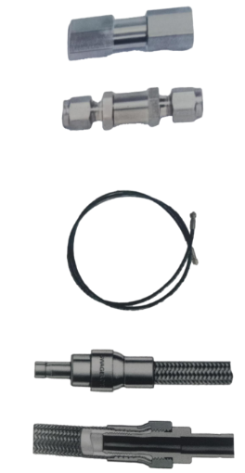
It must be noted, however, that adding a PTFE liner will slow the heat transfer rate into and out of the vessel, and it may be necessary to adjust the temperature control method to prevent overheating. Also these cannot be used in a reactor equipped with a cooling coil.

Safety check valves: Whenever gases or liquids are introduced into a vessel under pressure, the supply pressure must be greater than the pressure in the vessel to prevent reverse flow back into the supply system, protection against reverse flow can be obtained by installing a check valve in the supply line. With a check valve in the line, the valve will snap shut if the supply pressure is too low, or if the pressure in the pressure in the vessel should rise above the supply pressure. This protection is particularly important on stirred reactors where gas enters through a dip tube. With liquids in the vessel, any back pressure will force liquid back into the gas tank or into the gas supply system. These valve have a 10 psi normal cracking pressure and are rated for 200 bar maximum working pressures.

Pressure hose: Three different pressure hose assembles are available for high pressure gas connections to both stirred and non-stirred vessels. The standard length is 2 meters, or as per user requirement.

Flexible Nylon Hose: The hose is flexible nylon with ¼” OD stud at both ends that allows for attachment to most gas tank valves, pressure regulators or other gas supply sources. It is rated for 2500 psi and is very flexible and easy to use with dry. Non-corrosive gases (nitrogen, hydrogen, and oxygen). Care must be taken to ensure that the nylon hose does not cone in direct contact with any ho surfaces on the vessel or heater.

Braided, stainless steel hose with a PTFE lining: Braided, stainless steel hose with a PTFE lining, rated for 2500 psi. It is reasonably flexible and recommended for use with corrosive gases and liquids, and for applications requiring additional abrasion resistance, but it is not intended for high temperature liquids or gases. This hose is also with ¼” OD stud at both ends that allows for attachment to most gas tank valves, pressure regulators or other gas supply sources.

SS316 Tubing 1/8” OD: For high pressure 2-meter length of 1/8” OD stain –less steel tubing, rated for 7500 psi. The end connector can be 1/8” Nut or Reducer union (1/8” OD T to ¼” OD stub) this small diameter tubing can be bent, but it is not as flexible as the other hoses. It is recommended for corrosive gases, high temperature transfers and other high-pressure applications. Special versions of this assembly can be made of other corrosion resistant materials.

Temperature sensor: Indo offers a variety of thermos-couples for use in these reactors and pressure vessels. The “standard” thermocouple is a type K which is well suited to the operating temperature range of these vessel. Other materials as well as platinum resistance (RTD) elements are available as special orders.

These thermocouple are sealed in 3 mm diameter SS316 sheaths and have a standard round pin connection at the end of the probe. These thermocouple assemblies can either be sealed directly into the head of the vessel using a male connector or inserted into a protective thermos-well.

Thermowells are used on larger vessels to protect the thermocouple from physical damage and on all on all vessels of a corrosion resistant alloy other than stainless steel

The extension wire is used to connect the thermocouple to the control or readout device. The standard length is six feet, but longer lengths are available.

Materials of Construction

User has to select appropriate material of construction, stirred reactors, pressure vessels are normally made of stainless steel 316L. Typical composition of SS316 is

Material | Fe | Ni | Cr | Mo | Mn | Other
SS316L | 65 | 12 | 17 | 2.5 | 2.0 | Si 1.0

Type 316 stainless steel is an excellent material for use with most organic systems. A few organic acids and organic halides can, under certain conditions, hydrolyze to from inorganic halogen acids which will attack T316SS. Acetic, formic and other organic acids are routinely handled in T316SS.

T316SS is not normally the material of choice for inorganic acid systems. At room temperature it does offer useful resistance to dilute sulfuric, sulfurous, phosphoric and nitric acids. Other inorganic acids sulfuric, phosphoric and nitric acids readily attack T316SS at elevated temperatures and pressures.

Halogen acids attach all forms of stainless steel rapidly, even at low temperatures and in dilute solutions. Halogen salts can cause severe pitting in all stainless steels. Chlorides can cause stress corrosion cracking.

Although T316SS offers excellent resistance to surface corrosion by caustics. However, caustics can cause stress corrosion cracking in stainless pressure vessels. This phenomenon begins to appear at temperatures just above 100°C and has been the most common cause of corrosion failure in stainless laboratory vessels.

Monel 400
Typical composition of Monel 400 is

Material | Trade name | Ni | Cu | Fe
Alloy 400 | Monel 400 | 66 | 31.5 | 1.2

Alloy 400 is an alloy comprised essentially of two – thirds nickel and one-third copper. For many applications it offers about the same corrosion resistance as nickel, but with higher maximum working pressures and temperature and at a lower cost because of its greatly improved machinability.

Alloy 400 is widely used for caustic solutions because it is not subject to stress corrosion cracking in most applications. Chloride salts do not cause stress corrosion creaking in alloy 400.
It is also an excellent material for fluorine, hydrogen fluoride and hydrofluoric acid system. Alloy 400 is seldom the material of choice for hydrochloric and sulfuric acids due to its high copper content.

Alloy 400 is rapidly attacked by nitric acid and ammonia system due to high copper content.

Hastelloy C-276
Typical composition of hastelloy C276 is

Material | Trade name | Ni | Mo | Cr | Fe | W | Co | Mn
Alloy C276 | Hastelloy C276 | 53 | 16 | 15.5 | 6.5 | 4.0 | 2.5 | 1

Alloy C-276 is a Nickel – chromium – molybdenum alloy having perhaps the broadest general corrosion resistance of all commonly used allys. It was developed initially for use with wet chlorine, but it also offers excellent resistance to strong oxidizers such as cupric and ferric chlorides, and to a variety of chlorine compounds and chlorine contaminated materials, because of its broad chemical resistance, alloy C-276 is the second most popular alloy, following T316SS, for vessels used in research and development work.

Inconel 600
Typical composition of alloy 600 is

Material | Trade name | Ni | Cr | Fe
Alloy 600 | Monel 600 | 76 | 15.5 | 8

Alloy 600 is a high nickel alloy offering excellent resistance to caustics and chlorides at high temperatures and high pressure when sulfur compounds are present. In caustic environments, alloy 600 is unexcelled. It also is often chosen for its high strength at elevated temperatures. Although it can be recommended for a broad range of corrosive conditions, its cost often limits its cost often limits its use to only those applications where its exceptional characteristics are required.

Titanium

Titanium is an excellent material for use with oxidizing agents, such as nitric acid, aqua regain and other mixed acids. It also offers very good resistance to chloride ions. Reducing acids, such as sulfuric and hydrochloric, which have unacceptably high corrosion rates in their pure form can have their corrosion rates in titanium reduced to acceptable levels if relatively small quantities of oxidizing ions, such as cupric, ferric, nickel or even nitric acid are present to act as corrosion inhibitors. This phenomenon leads to many successful applications for titanium in the hydrometallurgy field where acids, particularly sulfuric acid, are used to leach ores. In these operations the extracted ions act as corrosion inhibitors. Prospective users must remember that titanium will burn vigorously in the presence of oxygen at elevated temperatures and pressures. While there have been many successful applications in hydrometallurgy where oxygen and sulfuric acid are handled in titanium equipment, the danger of ignition is always present and must be protected against whenever titanium and oxygen are used together.

Warranty conditions:

- Non-assignable: The warranties herein extend only to the original purchaser-user. These warranties or any claims based there –on are not assignable or transferable.
- Use of product: The warranties herein are applicable and enforceable only when the product.

- Is installed and operated in strict accordance with the written instructions for its use.
- Is being used in a lawful manner, and
- Has been stored or maintained in accordance to instructions provided by Indo aerogels and membranes.
- The user’s responsibility: Indo aerogels and membranes engineers and sales personnel will gladly discuss available equipment and material option with prospective users, but the final responsibility for selecting a reactor or pressure vessel which has the capacity, pressure rating, chemical compatibility, corrosion resistance and design feature required to perform safely and to the user’s satisfaction in any application or test must rest entirely with the user; not with Indo aerogels and membranes.

It is also the user’s responsibility to install the equipment in a safe operating environment and to train all operating personnel in appropriate safety, operational and maintenance procedures.

- Warranty period: Unless otherwise provided in writing by Indo aerogels and membranes, the warranties herein are applicable for a period of one year from date of delivery of the product to the original purchaser/user. Note, however, that there is no guarantee of a service life of one year after delivery.

- Notification: To enforce any warranty created herein, the purchaser/user must notify Indo aerogels and membranes in writing within thirty (30 days) of the date any defect is detected.

Upon request of Indo aerogels and membranes, the part or product involved must be returned to Indo aerogels and membranes in the manner specified by Indo aerogels and membranes for analysis and non-destructive testing.

Subject to the above conditions, Indo aerogels and membranes expressly warrants that its products:

1. Are as described in the applicable sales literature, or as specified in shipping documents.

2. Will function as described in corresponding Indo aerogels and membranes sales bulletins or, for
Specially engineered assemblies, as stated in the sales proposal and purchase agreement.

3. Will remain free from defects in materials and workmanship for the warranty period.

Limitations on the warranty:
As to the original purchase/ user Indo aerogels and membranes its liability for claims other than personal injury as follows:

1. Replacement or repair with respect to express warranties herein, Indo aerogels and membranes only obligation is to replace or repair any parts, assemblies or products not conforming to the warranties provided herein.

2. Disclaimer of consequential damages. In no event shall Indo aerogels and membranes be liable for consequential commercial damages, including but not limited to: damages for loss of use, damages for lost profits, and damages for resulting harm to property other than the Indo aerogels and membranes.

Indemnity and hold harmless.
Original purchase-user-agrees to indemnify and hold Indo aerogels and membranes harmless for any personal injuries to original purchase-user, its employees and all third parties where said injuries arise from misuse of Indo aerogels and membranes products or use not in accordance with specification and instructions for use supplied with the Indo aerogels and membranes products.

